**Wood Panel Wallpaper in Soft Grey**

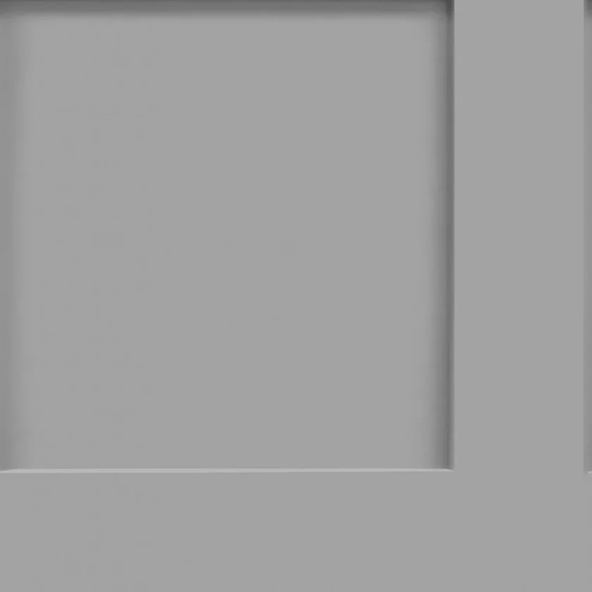Wood panel wallpaper in navy exudes a bold and timeless elegance, ideal for adding depth and sophistication to any room. The rich navy tones create a striking yet calming backdrop, while the vertical wood panel design adds texture and a sense of architectural charm. Subtle grain details enhance its authenticity, blending seamlessly with both modern and traditional interiors. Perfect for creating a dramatic feature wall in living rooms, bedrooms, or offices, this wallpaper offers a refined and versatile aesthetic, making any space feel both luxurious and inviting.